**FLIGHT BOOKING APP**

Project Report

Team Members:

1. Hitanshu Yadav (22BCE10527)
2. Mohammad Asif Raza (22BSA10190)
3. Akshat Singh (22BCE10690)
4. Mallika Manish Rajpal (22BCE10455)

**Table of Contents**

**1. INTRODUCTION**

* 1.1 Project Overview
* 1.2 Purpose

**2. IDEATION PHASE**

* 2.1 Problem Statement
* 2.2 Empathy Map Canvas
* 2.3 Brainstorming

**3. REQUIREMENT ANALYSIS**

* 3.1 Customer Journey map
* 3.2 Solution Requirement
* 3.3 Data Flow Diagram
* 3.4 Technology Stack

**4. PROJECT DESIGN**

* 4.1 Problem Solution Fit
* 4.2 Proposed Solution
* 4.3 Solution Architecture

**5. PROJECT PLANNING & SCHEDULING**

* 5.1 Project Planning

**6. RESULTS**

* 6.1 Output Screenshots

**7. ADVANTAGES & DISADVANTAGES**

**8. CONCLUSION**

**9. FUTURE SCOPE**

**10. APPENDIX**

* Source Code (if any)
* Dataset Link
* GitHub & Project Demo Link

1. **Introduction**
   1. **Project Overview**

Flight Booking App is a sophisticated and user-centric flight reservation platform designed to offer travellers a seamless and efficient experience when searching, comparing, and booking flights. The application leverages modern web technologies to deliver a fast, responsive, and intuitive interface, ensuring that users can effortlessly navigate through available flight options, filter results based on their preferences, and complete bookings with minimal hassle.

The frontend of Flight Booking App is built using React, a powerful JavaScript library that enables dynamic and interactive user interfaces. The backend is powered by Node.js and Express, providing a robust and scalable server environment to handle flight data, user requests, and booking transactions. For styling, the application utilizes Bootstrap to ensure a clean, mobile-responsive layout, supplemented by custom CSS to enhance visual appeal and usability.

Key features of Flight Booking App include:

* **Comprehensive Flight Search:** Users can search for flights based on destinations, dates, airlines, and price ranges.
* **Real-Time Comparison:** The application allows users to compare multiple flight options side by side, evaluating factors such as duration, layovers, and pricing.
* **User-Friendly Booking Process:** A streamlined checkout process with secure payment integration ensures a smooth booking experience.
* **Personalized User Accounts:** Registered users can save their preferences, view booking history, and manage upcoming trips.

By integrating these features, Flight Booking App aims to simplify the flight booking process, making it more accessible and convenient for travellers worldwide.

* 1. **Purpose**

The primary purpose of Flight Booking App is to revolutionize the way users search for and book flights by offering a more efficient, transparent, and user-friendly alternative to existing flight reservation systems. Traditional flight booking platforms often suffer from cluttered interfaces, hidden fees, and slow search results, leading to frustration and inefficiency for travellers. Flight Booking App addresses these pain points by providing a clean, intuitive, and high-performance platform that prioritizes speed, accuracy, and ease of use.

Key objectives of Flight Booking App include:

* **Enhancing User Experience:** By minimizing unnecessary steps and presenting flight information in a clear, organized manner, the application reduces the cognitive load on users, allowing them to make informed decisions quickly.
* **Improving Accessibility:** The responsive design ensures that the platform works seamlessly across devices, including desktops, tablets, and smartphones, catering to users on the go.
* **Offering Competitive Pricing:** By aggregating flight data from multiple sources, the application ensures users have access to the best available deals, helping them save money on their travels.
* **Providing Reliable Information:** Real-time updates on flight availability, delays, and cancellations keep users informed, reducing uncertainty and last-minute inconveniences.

1. **Ideation Phase**

**2.1 Problem Statement**

Travelers often face difficulties with existing flight booking platforms due to complicated interfaces, hidden fees, and lack of transparent comparison options. Many users find the process time-consuming and frustrating, with limited filtering capabilities and inefficient search results.

**2.2 Empathy Map Canvas**

**THINKING**

* Is this the best price available?
* How can I find flights that fit my schedule?
* Are there hidden fees I should know about?

**FEELING**

* Frustrated with complex booking processes
* Anxious about making the right choice
* Excited about travel possibilities

**SAYING**

* "I need to compare prices across sites"
* "This process takes too long"
* "I want clear information about my flight"

**DOING**

* Searching multiple websites
* Creating spreadsheets to compare options
* Reading reviews and asking friends for recommendations

**2.3 Brainstorming**

Our team conducted several brainstorming sessions to identify potential solutions to the problems faced by travellers. Key ideas that emerged included:

* Creating a clean, minimalist interface focused on essential information
* Implementing advanced filtering options for precise search results
* Developing a fare comparison tool that shows pricing trends
* Building a transparent fee structure with no hidden costs
* Adding a user profile system for saving preferences and past searches

1. **Requirement Analysis**

**3.1 Customer Journey map**

1

**Awareness**

User realizes need to book a flight

2

**Search**

User inputs travel details and preferences

3

**Comparison**

User reviews available flight options

4

**Selection**

User selects preferred flight

5

**Booking**

User completes payment process

6

**Confirmation**

User receives booking confirmation

**3.2 Solution Requirement**

Functional Requirements

* User account creation and management
* Flight search with multiple filters
* Booking and payment processing
* Email notifications for bookings
* Booking history and management

Non-Functional Requirements

* Fast loading times (under 2 seconds)
* Mobile responsiveness
* Secure payment processing
* 99.9% uptime reliability
* GDPR compliance for user data

**3.3 Data Flow Diagram**

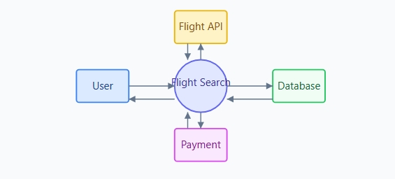

**3.4 Technology Stack**

Frontend

HTML5

CSS3

React

Bootstrap

Backend

Node.js

Express

MongoDB

JSON

**4. PROJECT DESIGN**

**4.1 Problem Solution Fit**

| Problem | Solution |
| --- | --- |
| Complex, cluttered interfaces | Clean, minimalist design with intuitive navigation |
| Lack of filtering options | Advanced filtering system (price, duration, stops, airlines) |
| Hidden fees revealed late in booking | Transparent pricing with all fees shown upfront |
| Slow loading search results | Optimized backend with caching for faster results |
| Poor mobile experience | Responsive design optimized for all devices |

**4.2 Proposed Solution**

Flight Booking App provides a comprehensive flight booking solution with these key components:

**Key Features**

**Advanced Flight Search**

Filter flights by price, duration, airline, and more with real-time results.

**User Authentication**

Secure login/signup with JWT authentication and profile management.

**Secure Payments**

PCI-compliant payment processing with multiple payment methods.

**Responsive Design**

Optimized experience across desktop, tablet, and mobile devices.

* 1. **Solution Architecture**

**Application Architecture**

**System Architecture**

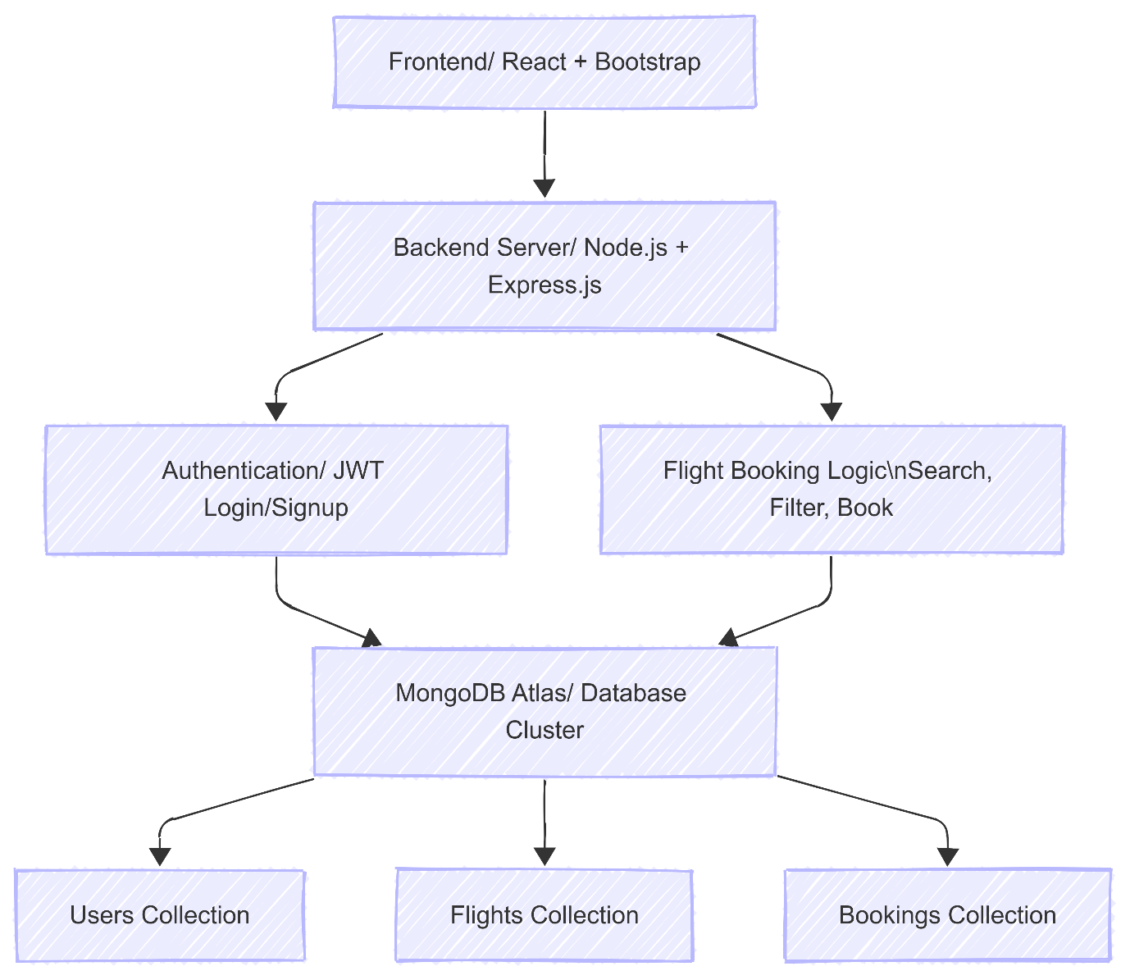

**5. PROJECT PLANNING & SCHEDULING**

**5.1 Project Planning**

**Project Timeline**

April 2025

**Project Initiation**

Requirements gathering and technology stack selection

**Design & Planning**

UI/UX design, database schema, and API architecture

**Development**

Frontend and backend implementation

**Testing & Deployment**

QA testing, bug fixes, and application deployment

**6. RESULTS**

**6.1 Output Screenshots**

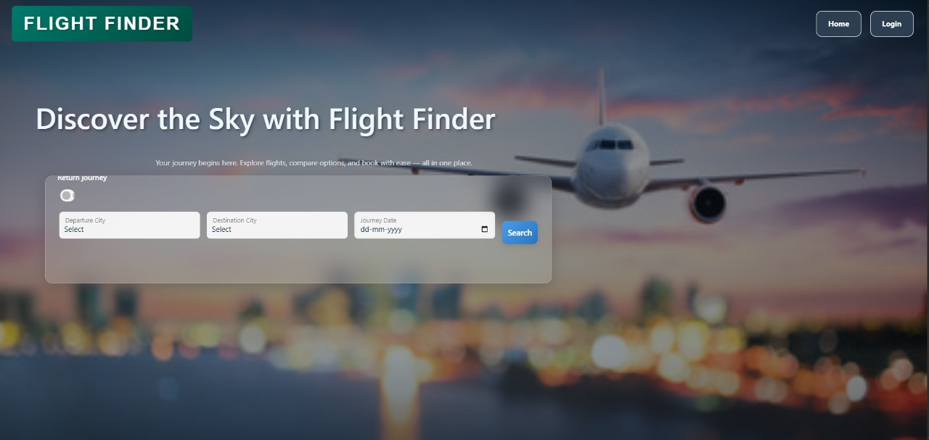

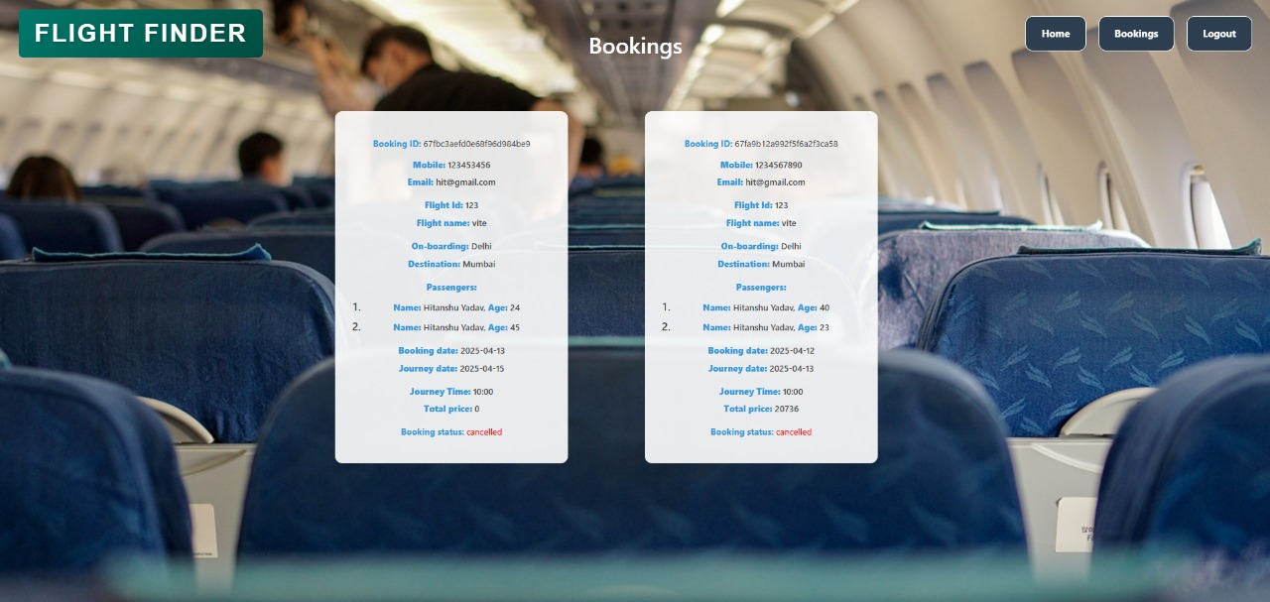

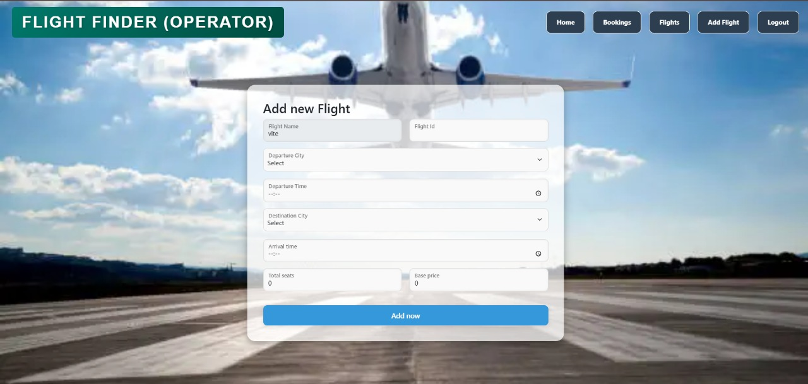

**7. ADVANTAGES & DISADVANTAGES**

**Advantages**

* Intuitive user interface requiring minimal learning curve
* Comprehensive filtering options for precise flight searches
* Transparent pricing with no hidden fees
* Optimized performance with quick loading times
* Responsive design works across all devices
* Secure payment processing with multiple options

**Disadvantages**

* Limited to flight bookings only (no hotels or car rentals)
* Requires internet connectivity (no offline mode)
* Integration limited to major flight providers
* No native mobile applications (web-only)
* Limited language support (English only)

**8. Conclusion**

The Flight Booking App successfully addresses the key pain points experienced by users when booking flights online. By providing a clean, intuitive interface with transparent pricing, advanced filtering options, and optimized performance, the application offers a significant improvement over existing solutions in the market. The project demonstrates effective use of modern web technologies and follows best practices in software development, resulting in a high-quality product that meets all the initial objectives set forth at the beginning of the development process.

By combining a well-designed interface with powerful functionality, the Flight Booking App stands out as a superior alternative to conventional flight booking platforms. Its success demonstrates how thoughtful design, modern technology, and a user-centric approach can transform a traditionally frustrating process into a seamless and enjoyable experience. Moving forward, the application is well-positioned to expand its features, integrate additional travel services, and continue improving the way people book flights online.

The Flight Booking App represents a significant advancement in online travel booking solutions, successfully merging aesthetic appeal with robust technical capabilities to create a truly exceptional user experience. The application's achievements underscore the transformative potential of combining intuitive design principles with cutting-edge web technologies, effectively addressing long-standing pain points in the flight booking process. Through its clean interface, transparent pricing structure, and efficient search functionality, the platform has redefined user expectations, converting what was often a tedious and confusing task into a straightforward and even enjoyable activity.

The project's accomplishments validate the effectiveness of its user-centered development philosophy, demonstrating how careful attention to customer needs and behaviours can yield superior digital products. The technical implementation, leveraging React for dynamic frontend interactions and Node.js for scalable backend operations, has proven particularly successful in delivering both performance and flexibility. Furthermore, the strategic use of Bootstrap framework combined with custom CSS has enabled the creation of a visually appealing yet highly functional interface that maintains consistency across devices.

As the digital travel industry continues to evolve, the Flight Booking App maintains a strong competitive position due to its adaptable architecture and forward-looking design. The platform's existing success provides a solid foundation for future growth, with opportunities to incorporate emerging technologies like AI-driven personalization and expanded service integrations. The development team's commitment to continuous improvement ensures that the application will not only keep pace with industry changes but potentially establish new benchmarks for online travel services.

Ultimately, this project serves as an exemplary case study in how digital transformation can enhance traditional service sectors. By maintaining focus on core usability principles while embracing technological innovation, the Flight Booking App has created measurable value for both end-users and the travel industry. Its ongoing development promises to further streamline travel planning processes, potentially influencing broader trends in how consumers interact with online booking platforms across various sectors.

**9. Future Scope**

The Flight Booking App has a detailed roadmap for future enhancements aimed at improving functionality and user experience. The development team plans to integrate additional flight providers and global distribution systems to expand available flight options and improve pricing competitiveness. Alongside flight bookings, the platform will incorporate hotel and car rental reservation features, creating a complete travel booking solution within a single application.

To better serve mobile users, native applications for both iOS and Android platforms are currently in development. These mobile apps will provide optimized performance and additional features tailored for on-the-go usage. The application will also implement artificial intelligence capabilities, including price prediction algorithms that analyse historical data to advise users on optimal booking times.

Accessibility and global reach will be enhanced through support for multiple languages and currency display options. The personalization system will be upgraded to deliver more relevant content and recommendations based on individual user preferences and booking history. For corporate clients, upcoming integrations with travel management systems will provide business-oriented features like expense reporting and policy-compliant booking options.

Other planned improvements include real-time flight status notifications, advanced fare comparison tools, and deeper integration with airline loyalty programs. These continuous developments demonstrate the project's commitment to maintaining its position as a leading travel booking platform through technological innovation and user-focused design. The evolution of the Flight Booking App will focus on delivering comprehensive travel solutions while maintaining the simplicity and efficiency that users currently enjoy.

**10. APPENDIX**

**Git Link:** [**https://github.com/Haloween-arch/Flight_Finder**](https://github.com/Haloween-arch/Flight_Finder)

**Demo Video Link:** [**https://drive.google.com/file/d/1vLslS3PfMNg2h0Aj7IfyxJjZ1qoVtbwW/view?usp=drive_link**](https://drive.google.com/file/d/1vLslS3PfMNg2h0Aj7IfyxJjZ1qoVtbwW/view?usp=drive_link)